Pre-compilation for the query
The query of a given user must be checked. To do that a syntax pre-compiler is necessary. First in a given file we describe the syntax. Then we create from this syntax a regular expression that will parse a given query.

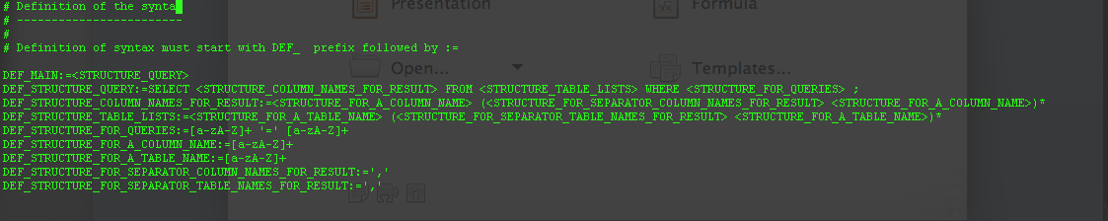
Full syntax
The given upper file screen copy , describe the syntax allowed.

To start reading it is necessary to have a DEF_MAIN flag. This is where we start reading the file that describe the syntax for the query.

Example of transformation

Left side there is the tag and right side there is the query transformed as a regular expression.

Below is the description at the beginning before the transformation:

Description of the query

The transformation works fine but some more tests need to be done.

